Assignment

Task 1: Image Selection and Preprocessing
• Load a surveillance-style image (street, corridor, parking area)
• Convert the image to grayscale
• Display the original image

import cv2
import matplotlib.pyplot as plt

image = cv2.imread('doc1.jpeg')

if image is None:
print("Error: Image not found.")
exit()

image_rgb = cv2.cvtColor(image, cv2.COLOR_BGR2RGB)

gray_image = cv2.cvtColor(image, cv2.COLOR_BGR2GRAY)

plt.figure(figsize=(10,5))

plt.subplot(1,2,1)
plt.title("Original Image")
plt.imshow(image_rgb)
plt.axis('off')

plt.subplot(1,2,2)
plt.title("Grayscale Image")
plt.imshow(gray_image, cmap='gray')
plt.axis('off')

plt.tight_layout()
plt.show()

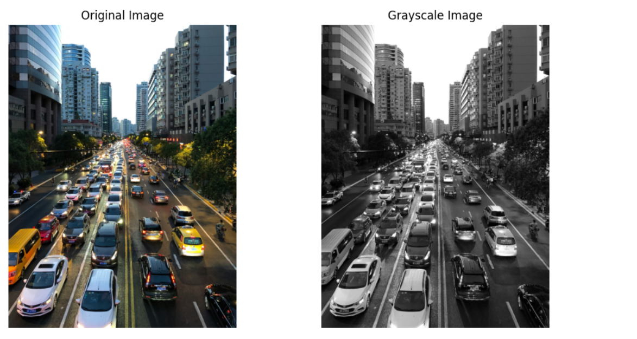
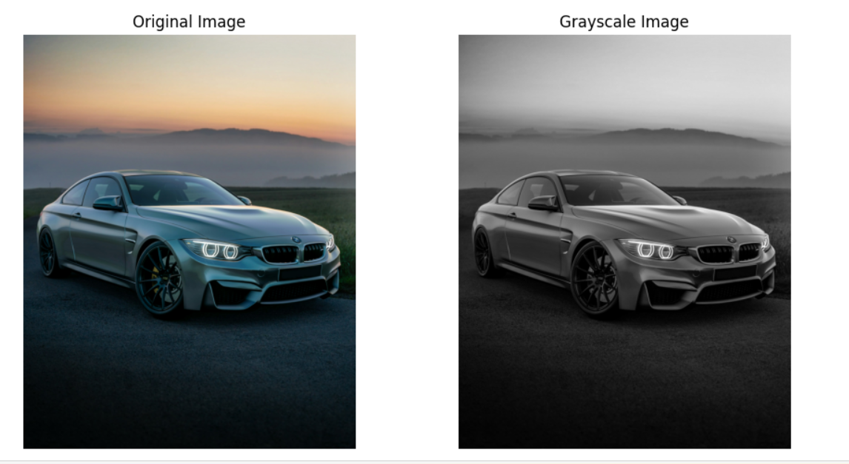

Task 2: Noise Modeling
• Simulate: o Gaussian noise (sensor noise)
o Salt-and-pepper noise (transmission errors)
• Display noisy images

import numpy as np
import cv2
import matplotlib.pyplot as plt

def add_gaussian_noise(image, mean=0, sigma=25):
gaussian = np.random.normal(mean, sigma, image.shape)
noisy_image = image + gaussian
noisy_image = np.clip(noisy_image, 0, 255)
return noisy_image.astype(np.uint8)

def add_salt_pepper_noise(image, salt_prob=0.02, pepper_prob=0.02):
noisy_image = np.copy(image)
salt = np.random.rand(*image.shape) < salt_prob
noisy_image[salt] = 255
pepper = np.random.rand(*image.shape) < pepper_prob
noisy_image[pepper] = 0
return noisy_image

gaussian_noisy = add_gaussian_noise(gray_image)
sp_noisy = add_salt_pepper_noise(gray_image)

plt.figure(figsize=(12,6))

plt.subplot(1,3,1)
plt.title("Original Grayscale")
plt.imshow(gray_image, cmap='gray')
plt.axis('off')

plt.subplot(1,3,2)
plt.title("Gaussian Noise")
plt.imshow(gaussian_noisy, cmap='gray')
plt.axis('off')

plt.subplot(1,3,3)
plt.title("Salt & Pepper Noise")
plt.imshow(sp_noisy, cmap='gray')
plt.axis('off')

plt.tight_layout()
plt.show()

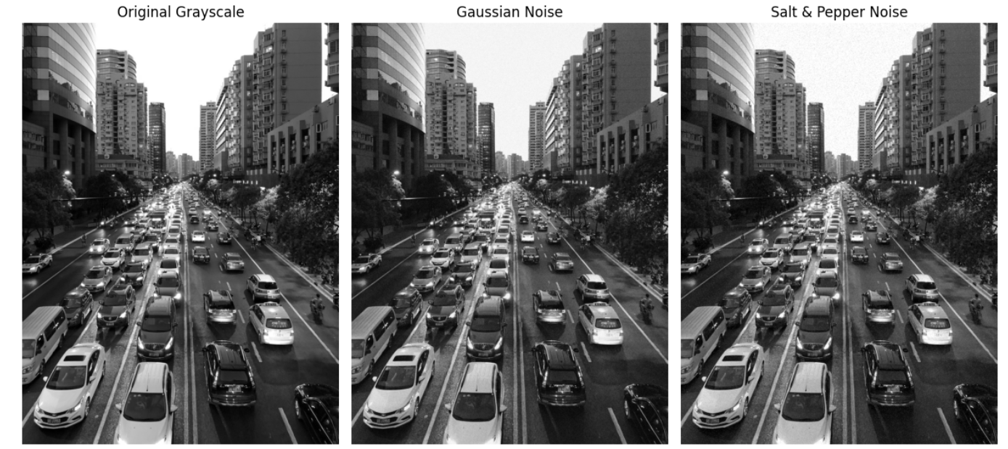
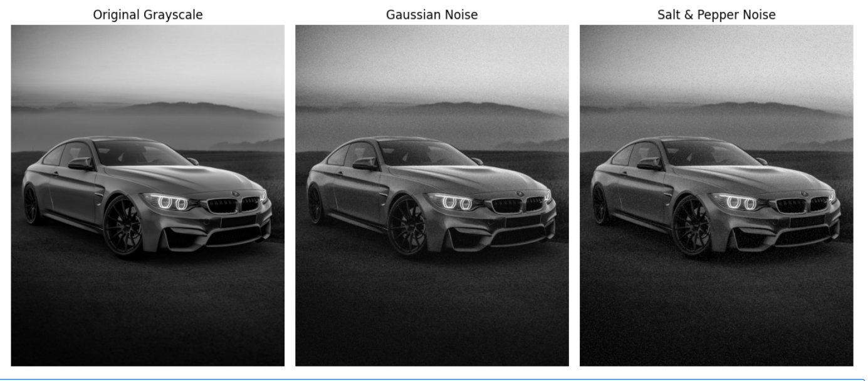
Task 3: Image Restoration Techniques
• Apply spatial filters: o Mean filter
o Median filter
o Gaussian filter
• Observe noise suppression and detail preservation

import cv2
import matplotlib.pyplot as plt

mean_gaussian = cv2.blur(gaussian_noisy, (5,5))
median_gaussian = cv2.medianBlur(gaussian_noisy, 5)
gaussian_gaussian = cv2.GaussianBlur(gaussian_noisy, (5,5), 0)

mean_sp = cv2.blur(sp_noisy, (5,5))
median_sp = cv2.medianBlur(sp_noisy, 5)
gaussian_sp = cv2.GaussianBlur(sp_noisy, (5,5), 0)

plt.figure(figsize=(14,8))

plt.subplot(2,4,1)
plt.title("Gaussian Noisy")
plt.imshow(gaussian_noisy, cmap='gray')
plt.axis('off')

plt.subplot(2,4,2)
plt.title("Mean Filter")
plt.imshow(mean_gaussian, cmap='gray')
plt.axis('off')

plt.subplot(2,4,3)
plt.title("Median Filter")
plt.imshow(median_gaussian, cmap='gray')
plt.axis('off')

plt.subplot(2,4,4)
plt.title("Gaussian Filter")
plt.imshow(gaussian_gaussian, cmap='gray')
plt.axis('off')

plt.subplot(2,4,5)
plt.title("Salt & Pepper Noisy")
plt.imshow(sp_noisy, cmap='gray')
plt.axis('off')

plt.subplot(2,4,6)
plt.title("Mean Filter")
plt.imshow(mean_sp, cmap='gray')
plt.axis('off')

plt.subplot(2,4,7)
plt.title("Median Filter")
plt.imshow(median_sp, cmap='gray')
plt.axis('off')

plt.subplot(2,4,8)
plt.title("Gaussian Filter")
plt.imshow(gaussian_sp, cmap='gray')
plt.axis('off')

plt.tight_layout()
plt.show()

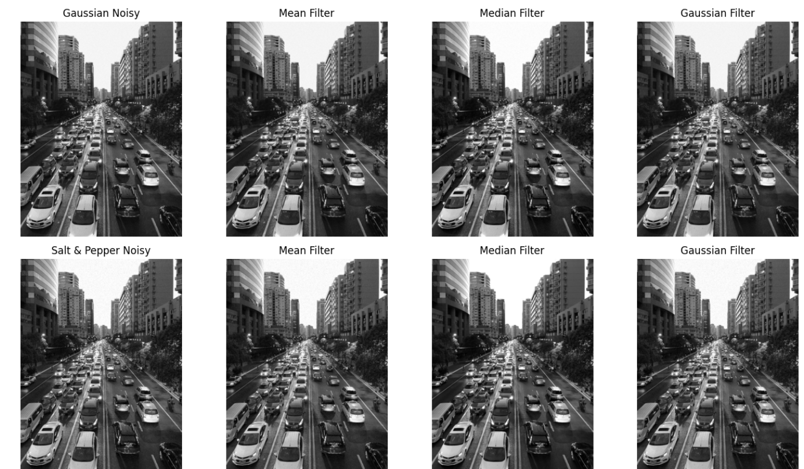
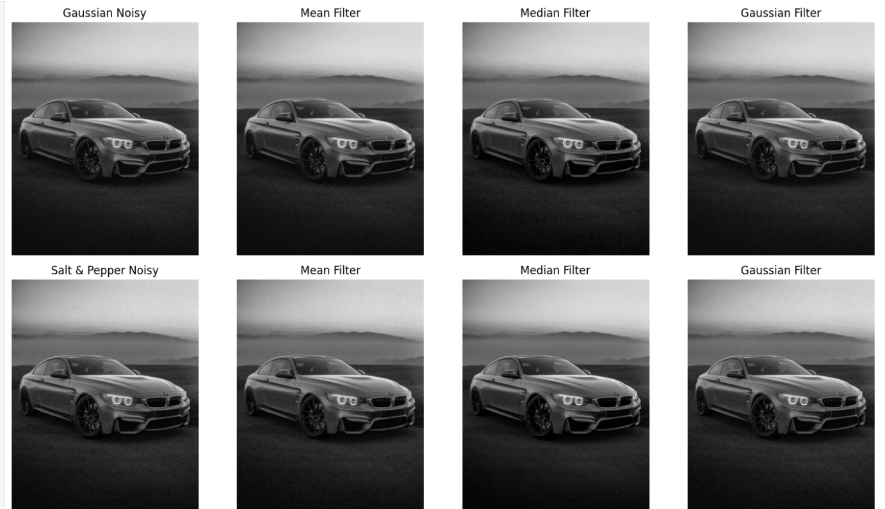

Task 4: Performance Evaluation
• Compute: o Mean Squared Error (MSE)
o Peak Signal-to-Noise Ratio (PSNR)
• Compare restored images with original

mean_gaussian = cv2.blur(gaussian_noisy, (5,5))
median_gaussian = cv2.medianBlur(gaussian_noisy, 5)
gaussian_gaussian = cv2.GaussianBlur(gaussian_noisy, (5,5), 0)

mean_sp = cv2.blur(sp_noisy, (5,5))
median_sp = cv2.medianBlur(sp_noisy, 5)
gaussian_sp = cv2.GaussianBlur(sp_noisy, (5,5), 0)

plt.figure(figsize=(14,8))

plt.subplot(2,4,1)
plt.title("Gaussian Noisy")
plt.imshow(gaussian_noisy, cmap='gray')
plt.axis('off')

plt.subplot(2,4,2)
plt.title("Mean Filter")
plt.imshow(mean_gaussian, cmap='gray')
plt.axis('off')

plt.subplot(2,4,3)
plt.title("Median Filter")
plt.imshow(median_gaussian, cmap='gray')
plt.axis('off')

plt.subplot(2,4,4)
plt.title("Gaussian Filter")
plt.imshow(gaussian_gaussian, cmap='gray')
plt.axis('off')

plt.subplot(2,4,5)
plt.title("Salt & Pepper Noisy")
plt.imshow(sp_noisy, cmap='gray')
plt.axis('off')

plt.subplot(2,4,6)
plt.title("Mean Filter")
plt.imshow(mean_sp, cmap='gray')
plt.axis('off')

plt.subplot(2,4,7)
plt.title("Median Filter")
plt.imshow(median_sp, cmap='gray')
plt.axis('off')

plt.subplot(2,4,8)
plt.title("Gaussian Filter")
plt.imshow(gaussian_sp, cmap='gray')
plt.axis('off')

plt.tight_layout()
plt.show()
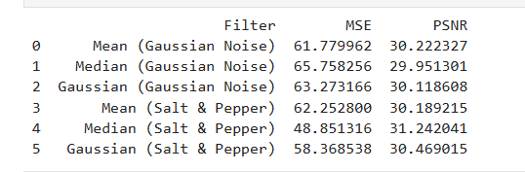
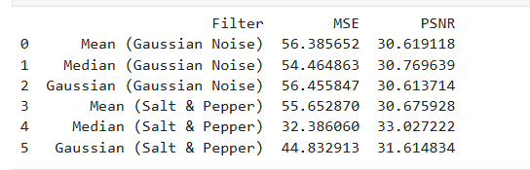

Task 5: Analytical Discussion
• Print filter-wise performance comparison
• Identify the best restoration method for each noise type
• Justify results based on theory

best_gaussian = df.iloc[0:3].loc[df.iloc[0:3]["PSNR"].idxmax()]
best_sp = df.iloc[3:6].loc[df.iloc[3:6]["PSNR"].idxmax()]

print("\nPerformance Comparison:")
print(df)

print("\nBest Filter for Gaussian Noise:")
print(best_gaussian)

print("\nBest Filter for Salt & Pepper Noise:")
print(best_sp) 